**NetView Desktop:** The second-to-last option on the Application tab is labeled “NetView Desktop.”

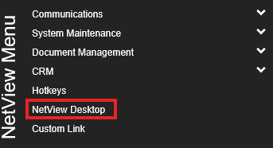

If clicked, it opens another copy of the NetView Desktop without requiring you to log in again.  Depending on the Internet browser used, the new desktop will open either in a new tab or a new window.  If you are using older NetView applications which can only run on Internet Explorer, this allows you to have two or more applications open in your web browser at the same time (currently you can only run one such application at a time in NetView Desktop).  Note that once all NetView applications become browser-independent, i.e. able to run on all web browsers (not just Internet Explorer), you will be able to run as many programs as you want at any time.

***TIP:*** If you have two monitors, you can drag one desktop to your second monitor.